Lahari Youth Festival 29/12/20211

Lahari Youth Festival is a district level literary and cultural programs conducted at GDC Mylavaram. SRR college students participated in various events like essay writing, elocution, painting, singing and dancing etc. Our students achieved prizes in Essay Writing and Elocution and awarded certificates.

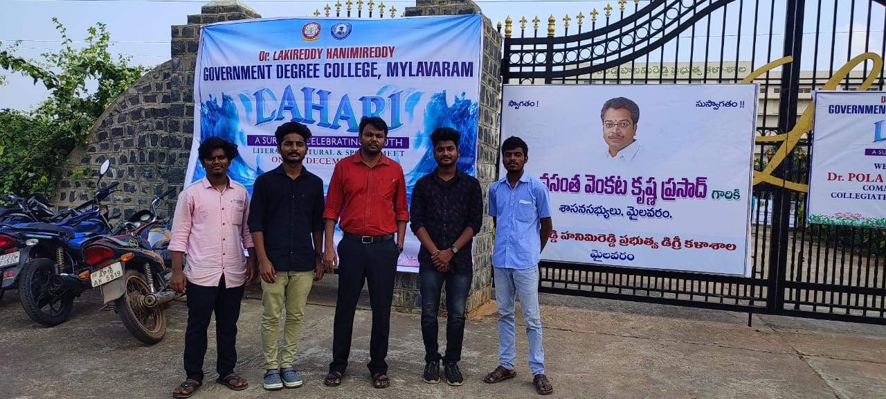

National Youth Day 06/01/2022

On the occasion of birthday of Nethaji Subhs Chandra Bose, National Youth Day was celebrated by Government of Andhra Pradesh. In this connection, district level competitions were conducted at Ghantasala Kala Kshetram, Vijayawada. Our college students participated in various literary and cultural programs and won prizes in essay writing, elocution, group singing and group dancing etc.

